

B.M.S. COLLEGE OF ENGINEERING
(Autonomous Institution, Affiliated to VTU, Belagavi)
Bull Temple Road, Basavanagudi, Bengaluru – 560 019
SYNOPSIS REPORT ON
“INTELLIGENT ECG SIGNAL DENOISING”
Submitted partial fulfilment of the requirement for completion of
MINI PROJECT [23EC5PWMPR]

Submitted by
Name of the Student | USN
CHIRANTH A | 1BM24EC044
D UTKARSHA | 1BM24EC048
DEEPAK SR | 1BM24EC051
DHANUSH G | 1BM24EC053

Under the guidance of
Dr. ARCHANA H R
Assistant Professor,
DEPARTMENT OF ELECTRONICS AND COMMUNICATION ENGINEERING
BMS College of Engineering,
Bull Temple Road, Basavanagudi, Bengaluru-560019

Academic Year
2026 – 27

CONTENTS

Sl. No. | Topic | Page No.
1 | AREA OF APPLICATION/WORK/DOMAIN | 1
2 | INTRODUCTION | 1
3 | LITERATURE SURVEY | 2
4 | PROBLEM DEFINATION | 3
5 | PROPOSED SOLUTION/BLOCK DIAGRAM | 4
6 | PROJECT EXECUTION STEPS | 5
7 | ESTIMATED BILL OF MATERIALS | 5
8 | REFERENCES | 6
9 | ADDITIONAL INFORMATION | 6
10 | GUIDE RECOMMENDATION | 7
11 | REMARKS FROM REVIEWERS | 7

- INTELLIGENT ECG SIGNAL DENOISING

1.1 AREA OF APPLICATION / WORK / DOMAIN:
Biomedical Signal Processing, Edge Artificial Intelligence, Wearable Healthcare, ECG Signal Processing and Low-Power Embedded Systems
The project focuses on processing electrocardiogram (ECG) signals for wearable and continuous health-monitoring applications. It combines biomedical signal processing with Edge AI to identify different types of ECG noise and perform efficient noise suppression on-device.

1.2 INTRODUCTION:
Electrocardiography (ECG) is an important technique used for monitoring the electrical activity of the heart. ECG signals obtained from wearable electrodes are often affected by unwanted noise such as baseline wander, power-line interference, high-frequency electromyographic (EMG) noise and motion artifacts. These disturbances can reduce the quality of the ECG signal and affect further analysis.
Conventional ECG systems generally use fixed digital filters to suppress noise. However, fixed filtering has limited adaptability when the noise conditions change. Advanced adaptive and machine-learning-based methods can provide better noise identification, but they may require higher computational resources, memory and power. This project proposes an intelligent low-power ECG noise suppression system using Edge AI, where noise conditions are identified locally and an appropriate filtering operation can be selected. The proposed work is being directed towards a 1D CNN-based noise classification approach, supported by knowledge distillation to obtain a lightweight model suitable for edge implementation.
This project proposes an intelligent low-power ECG noise suppression system using Edge AI, where noise conditions are identified locally and an appropriate filtering operation can be selected. The proposed work is being directed towards a 1D CNN-based noise classification approach, supported by knowledge distillation to obtain a lightweight model suitable for edge implementation. The overall system targeted toward efficient implementation on GPX10.
The main objective is to achieve low-power, low-latency and hardware-efficient ECG processing while maintaining effective noise identification and suppression for continuous wearable ECG monitoring. This follows the project's stated goals of low power, low latency, on-device intelligence and hardware efficiency.

1.3. LITERATURE SURVEY:
Ref. | Paper Title | Key Idea | Method / Approach | Key Findings / Contribution | Gaps
[1] | ECG Signal Denoising and Baseline Wander Correction Based on Empirical Mode Decomposition (2008) | Signal-processing techniques can separate unwanted components from ECG signals and reduce baseline wander. | Empirical Mode Decomposition (EMD)-based ECG signal decomposition and denoising. | Demonstrates the use of signal decomposition for reducing ECG interference while retaining useful signal characteristics. | Conventional signal-processing approach lacks AI-based adaptive noise identification and may not provide the low-power intelligent decision-making targeted in our project.
[2] | DeepCEDNet: An Efficient Deep Convolutional Encoder-Decoder Networks for ECG Signal Enhancement (2021) | Deep learning can be used for automatic ECG noise removal while preserving important ECG characteristics. | Deep convolutional encoder-decoder network for ECG signal enhancement and denoising. | Demonstrated effective ECG noise removal using a deep-learning architecture. | Computational requirements may still be high for very low-power edge devices; it does not specifically focus on lightweight noise-type classification and adaptive filter selection.
[3] | ECG Arrhythmia Classification Using STFT-Based Spectrogram and Convolutional Neural Network (2019) | A 1D ECG waveform can be represented as a 2D time-frequency spectrogram for CNN-based analysis. | Short-Time Fourier Transform (STFT) followed by a 2D CNN for ECG classification. | Demonstrated the effectiveness of spectrogram-based 2D CNN analysis of ECG signals. | Focuses primarily on arrhythmia classification rather than identifying different ECG noise types for adaptive noise suppression.
[4] | Atrial Fibrillation Detection on Low-Power Wearables Using Knowledge Distillation (2021) | Knowledge distillation can reduce the computational and memory requirements of AI models for wearable devices. | A larger neural network teaches a smaller student model using knowledge distillation; the model was optimized for low-power deployment. | Reduced the memory footprint and number of operations while improving the F1 score after quantization. The model was demonstrated on a Nordic nRF52832 SoC | Focuses on atrial-fibrillation detection rather than ECG noise classification and noise suppression.
[5] | Research on a Lightweight Arrhythmia Classification Model Based on Knowledge Distillation for Wearable Single-Lead ECG Monitoring Systems (2024) | Knowledge distillation can create highly compressed ECG AI models suitable for wearable devices. | Teacher-student knowledge distillation with a lightweight student model for single-lead ECG classification. | Achieved 96.32% accuracy with a 1242.58× model compression ratio and demonstrated real-time operation on an embedded system. | Targets arrhythmia classification rather than classification of ECG noise types; the approach is not specifically designed for adaptive noise-filter selection.

Table 1.1 - Literature Survey

1.3.2 Short observation from the Literature Survey:
There is still scope to combine these ideas into a low-power ECG noise-identification and suppression system in which a lightweight 1D CNN identifies different noise conditions and the result is used to select an appropriate filtering operation. This directly supports the research gap stated in your project: adapting to changing noise while minimizing computation, latency, memory and hardware resources.

1.4 PROBLEM DEFINITION:
- ECG Noise and Signal Quality: ECG signals acquired from wearable devices are often affected by unwanted noise such as baseline wander, 50 Hz power-line interference, high-frequency/EMG noise and motion artifacts. The main challenge is to suppress these different types of noise without distorting important ECG characteristics such as the P-wave, QRS complex and T-wave.
- Need for Intelligent and Low-Power Processing: Conventional fixed filters have limited adaptability when the noise conditions change, while advanced adaptive and AI-based methods can require higher computational resources, memory and power. Therefore, an efficient system is required that can identify the noise condition and select an appropriate filtering method while maintaining low latency and low hardware resource usage.
- Real-Time Edge Processing: Continuous ECG monitoring requires real-time processing so that noise can be detected and suppressed without depending heavily on external computing systems. The proposed system therefore aims to use Edge AI with a lightweight model to perform noise identification directly on the target hardware, providing a low-power, low-latency and hardware-efficient solution for wearable ECG monitoring.
1.5 PROPOSED SOLUTION:
- ECG Acquisition and Preprocessing: The ECG signal is acquired using an ECG Analog Front End (AFE) and converted into a suitable digital signal for processing. The acquired signal is then preprocessed and divided into suitable segments, which are transformed into a 2D representation suitable for the proposed 2D CNN-based noise classification approach.
- AI-Based Noise Identification: A 2D CNN is used to analyze the ECG representation and identify the type of noise present in the signal. Knowledge distillation is incorporated to transfer the learning capability of a larger teacher model into a lightweight student model, reducing the computational and memory requirements while maintaining effective noise classification for edge deployment.
- Intelligent Filtering and Hardware Implementation: Based on the identified noise condition, an appropriate digital filtering technique is selected to suppress the unwanted noise while preserving the important ECG waveform characteristics. The complete processing architecture is targeted for low-power implementation on GPX10, with emphasis on low latency, reduced hardware resources and future ASIC-oriented implementation.
1.5.1 Block Diagram:
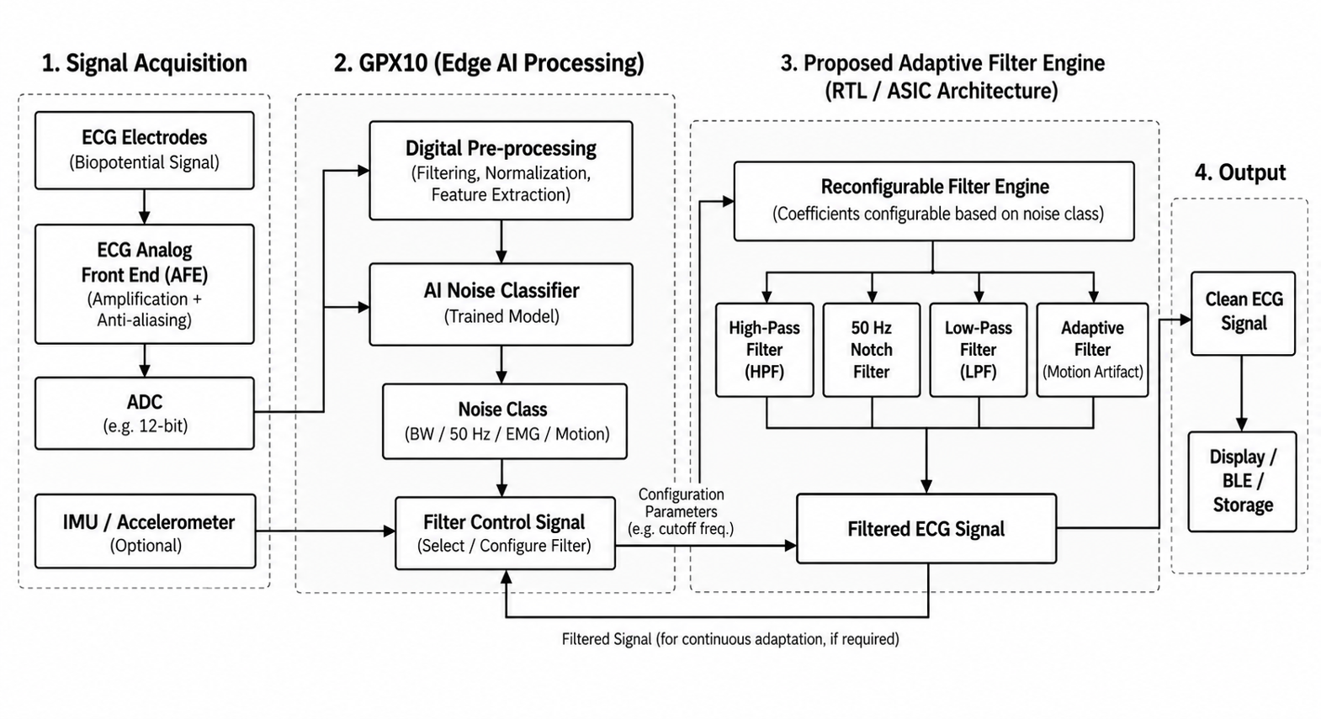
Fig 1.1 - Flow of Events of the proposed system

1.6 PROJECT EXECUTION STEPS:
- Literature Study and Dataset Collection: Study existing ECG noise-suppression and Edge AI techniques and collect suitable ECG datasets containing clean and noisy ECG signals. Identify and organize different noise conditions such as baseline wander, power-line interference, EMG noise and motion artifacts.
- ECG Data Preparation and Labelling: Preprocess the collected ECG signals, divide them into suitable segments and label the signals according to the type of noise present. Generate an appropriate 2D representation of the ECG data required for training the 2D CNN model.
- Knowledge Distillation and Model Optimization: Use a larger teacher model to transfer knowledge to a lightweight student model. Optimize the student model to reduce computational complexity, memory requirements and power consumption while maintaining suitable classification performance.
- Digital Filter Design and Integration: Design suitable digital HPF, LPF, notch and adaptive/reconfigurable filters for the identified ECG noise conditions. Determine appropriate filter parameters and coefficients based on the ECG sampling frequency, and integrate the filters with the AI-based noise classification stage for automatic filter selection.
- ECG Hardware Implementation: Interface the ECG Analog Front End (AFE) with the target hardware and establish the digital ECG processing pipeline. Implement the lightweight AI model and intelligent filtering stages on GPX10 for low-latency and low-power operation.
- Testing and Performance Evaluation: Test the complete system using different ECG noise conditions and evaluate noise suppression, ECG signal quality, processing latency, power consumption and hardware resource utilization. Compare the results with conventional filtering approaches.
1.7 ESTIMATED BILL OF MATERIALS:
Sl. No. | Component / Tool | Qty. | Estimated Price (₹)
1 | GPX10 Development Board | 1 | 5,000
2 | Connecting / Jumper Wires | 1 set | 50
3 | Breadboard | 1 | 70
4 | Matlab / Python | - | Free
5 | ECG Electrodes | 1 set | ₹500
6 | MIT-BIH ECG Dataset | - | Free
7 | Laptop | - | Existing
Total Estimate Budget |  | 5620

Table 1.2 – Estimated Components Prices

1.8 REFERENCES:
- Research Papers and Technical Literature: Research papers related to ECG signal denoising, ECG noise classification, 2D CNN-based ECG analysis, knowledge distillation, wearable ECG systems and low-power Edge AI are being studied to understand existing approaches and identify suitable techniques for the proposed system.
- ECG Datasets: Publicly available ECG datasets will be used for developing and evaluating the noise classification and filtering stages. The datasets will be analysed and appropriately labelled according to different ECG noise conditions.
- Hardware and Development Resources: Technical documentation and development resources related to the GPX10 platform and the selected Nordic ECG Analog Front End (AFE) will be referred to for hardware implementation and interfacing.
1.9 ADDITIONAL INFORMATION:
- Project Implementation: The project focuses on developing a low-power ECG processing system in which AI-based noise identification is combined with digital filtering for intelligent and efficient ECG noise suppression.
- AI Optimization: Knowledge distillation will be used to obtain a lightweight student model suitable for edge deployment, with emphasis on reducing computational complexity, memory usage and power consumption.
- Hardware-Oriented Design: The complete architecture will be designed with low latency and hardware efficiency in mind, making it suitable for implementation on GPX10 and providing a foundation for future ASIC-oriented development.

